**KING FAHD UNIVERSITY OF PETROLEUM AND MINERALS**

**DEPARTMENT OF PHYSICS**

**PHYS 441-221 Particle Physics**

**Major Exam-2 Solutions**

**14/11/2022; 06:00-08:00 PM**

**NAME**

**ID #**

**Q1. (5 points)**

Imagine that the photon, instead of being a massless vector (Spin 1) particle, were a massive scalar particle (Spin 0). Specifically, suppose the QED vertex factor were

$$ig_{e}1$$

(where $1$ is the $4×4$ unit matrix), and the ‘photon’ propagator were

$$\frac{-i}{q^{2}-{\left(m_{γ}c\right)}^{2}}$$

1. Find the amplitude, $M$, for electron-muon scattering, in this theory.
2. Calculate the spin-averaged quantity, $〈{\left|M\right|}^{2}〉$

**Solution**





**Q2. (5 points)**



**Solution**



**Q2. (5 points)**

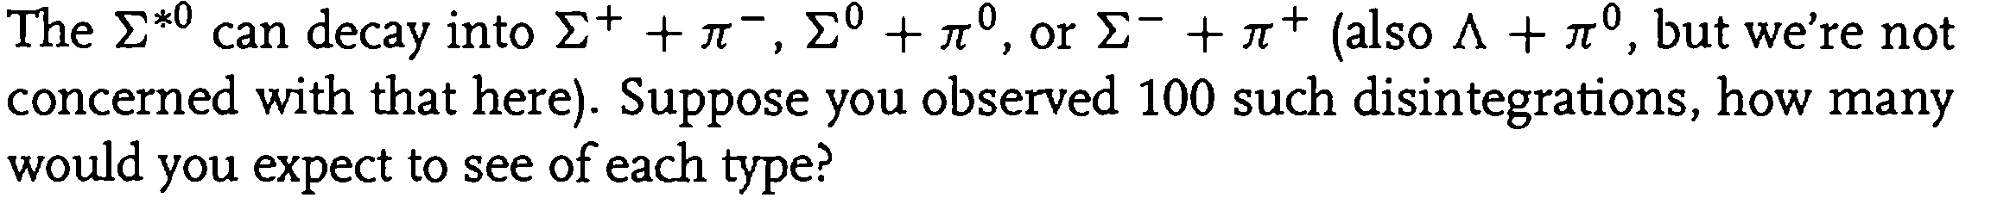

**Solution**

